**Medina, Angelo D.**

**Cinto, Albert**

**Valenzuela, Jeremy Terrence D.**

**Finals Project in OOP/Info Management**

**Steps on How to use Our System:**

1. First you need to Run the LoginForm.java.

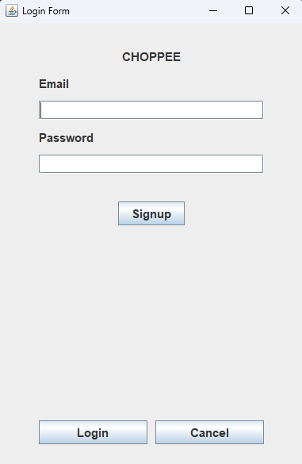

1. Then if you have already an account just login your account, but since you are a new user, you need to Signup first.

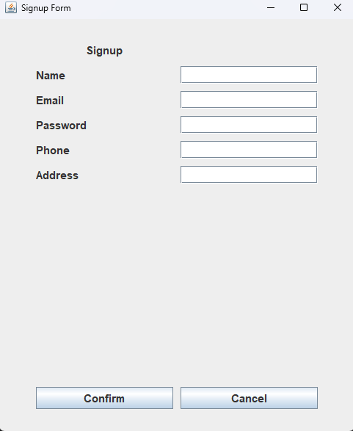

1. Once you already Signup your Account Information there’s a popup message that will shown that.

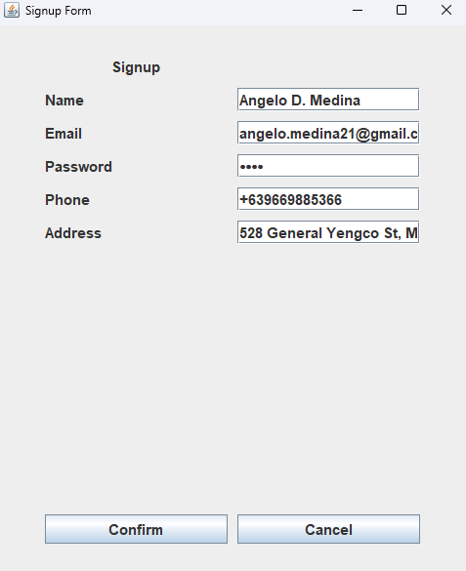

1. When Signup successful showed you will go to Login Page Directly, just put the Email and Password that you applied in Signup.

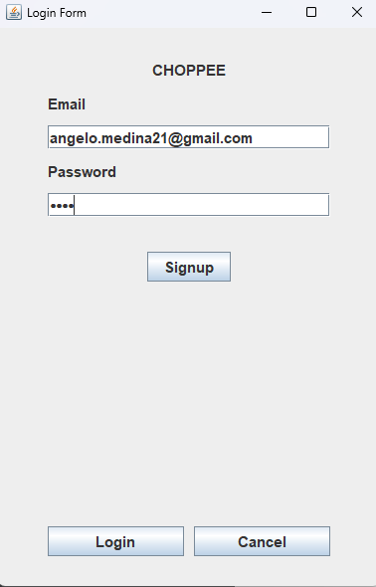

**Then press Login**

1. Next, once you’ve already Login you will go to our Main Page which is our Ordering System.

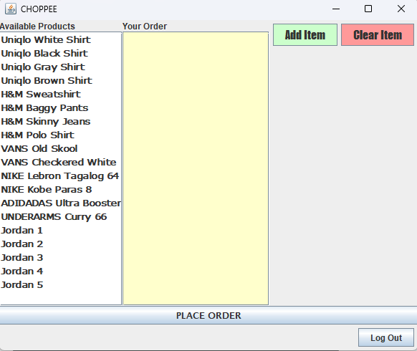

1. Next you just need to select any of our product and just click Add.

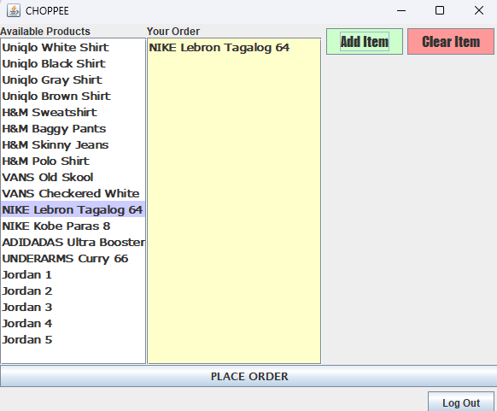

1. If you change your mind, you just clear the Item.

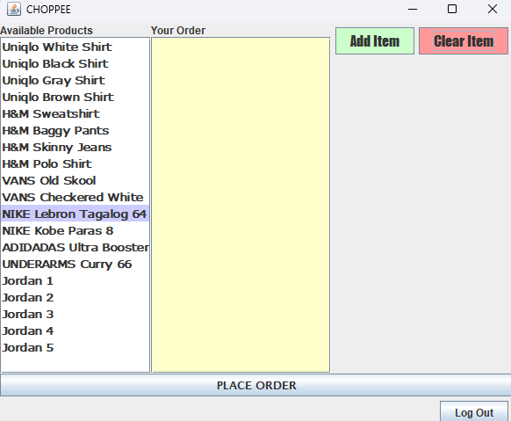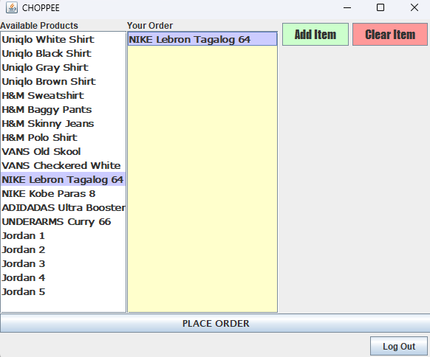

1. Back to Step 7, once you added your order, you can now proceed in Placing your Order.

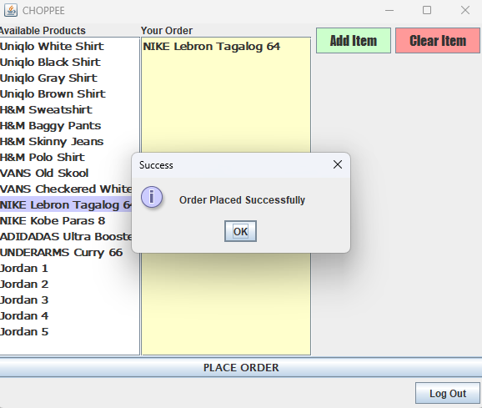

1. Then your Order Placed Successfully, that’s it, Next is I will show our database that stored the User Information and the Ordered that they Added.

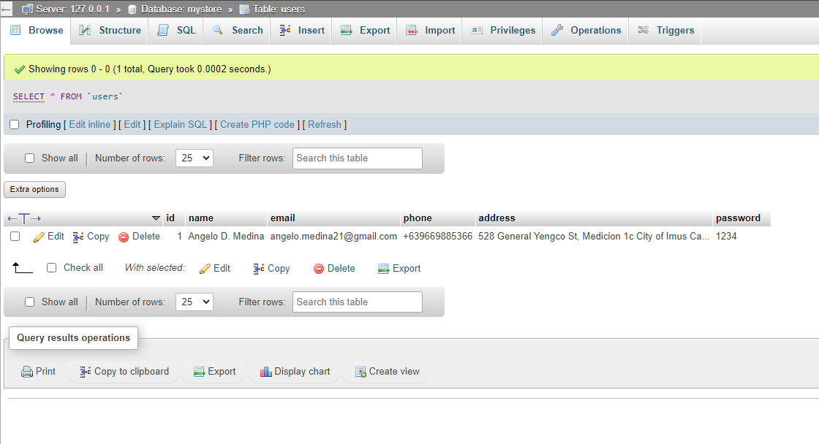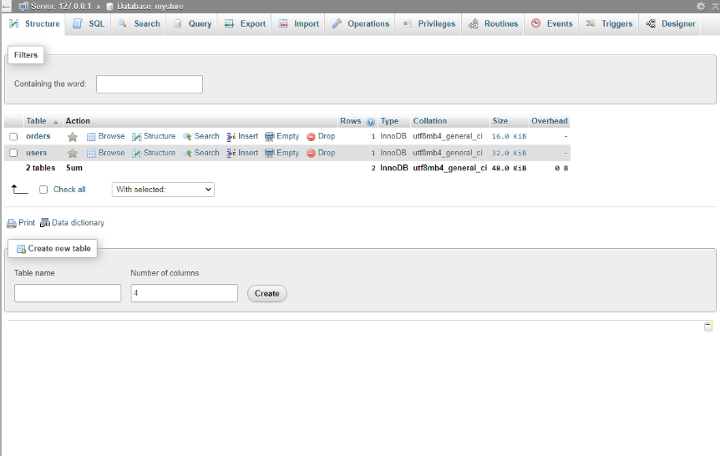

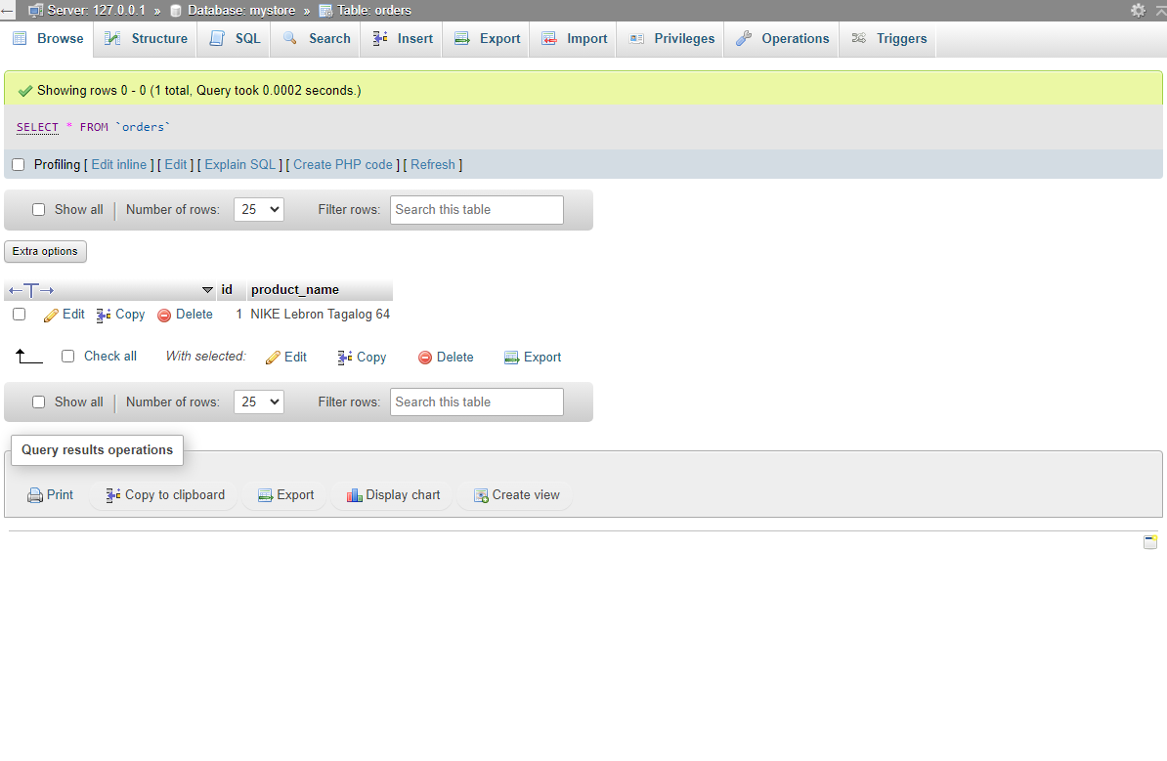

1. That’s all, Thank You!!